LAB REPORT实验报告
Lab Title | C++ Files |  |  |  | Lab No. | 15
Stud. Name | Jiang Yunxiang | Major | CST |  | Class
Student ID | 2022102330 |  | Date | 6/2
Lab description/objectives:
Write a C++ program that implements flipping the contents of each line of a string in a text file and outputs the flipped result to another text file. Both the input file name and output file name are specified by the user.

Source code:
（Paste the source code here）
#include<iostream>
#include<fstream>
#include<string>
using namespace std;

int main()
{
string input_file, output_file;
cout << "Please enter the name of input file:";
cin >> input_file;
cout << endl;
cout << "Please enter the name of output file:";
cin >> output_file;
cout << endl;
ofstream input(input_file);
ofstream output(output_file);
cout << "Enter anything into the input_file:";
string content;
getline(cin, content);
getline(cin, content);
cout << endl;
input << content;
input.close();
ifstream input1(input_file);
string getcontent;
while (getline(input1, getcontent))
{
reverse(getcontent.begin(), getcontent.end());
output << getcontent;
}
cout << "The input has been flipped and stored in the output file which is: ";
output.close();
ifstream output1(output_file);
string getcontent1;
while (getline(output1, getcontent1))
{
cout << getcontent1<<endl;
}

input1.close();
output1.close();
system("pause");
return 0;
}
Program outputs:
（Paste the screenshot of program output here）
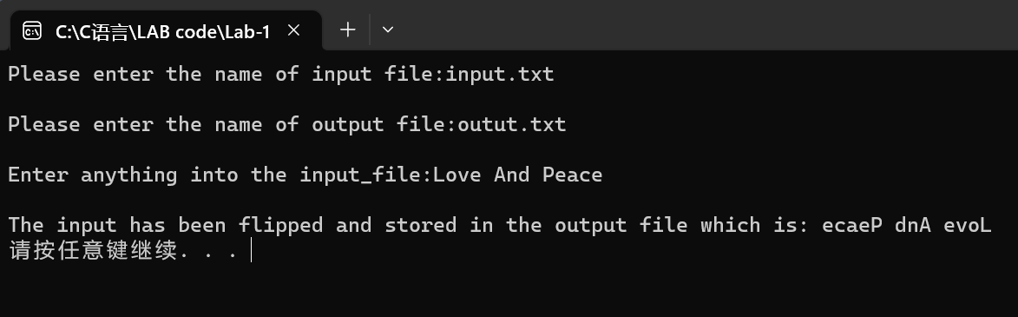
Discussion:
1．Most difficult parts
（What were the most difficult parts of your program to implement?）
Nope
2．Bugs and/or Errors
(List all the program bugs/errors you encountered and how you corrected them.)
Nope

